**Exercise No.:10**

**Register No:1518102066**

**Date:21.11.20**

**Aim:**

To write a python program print the number of upper case letters and lower case letters in a given string.

**Program:**

def string_test(s):

d={"UPPER_CASE":0, "LOWER_CASE":0}

for c in s:

if c.isupper():

d["UPPER_CASE"]+=1

elif c.islower():

d["LOWER_CASE"]+=1

else:

pass

print("Original String : ", s)

print("No. of Upper case characters : ",d["UPPER_CASE"])

print("No. of Lower case characters : ",d["LOWER_CASE"])

string_test('Sona College of Technology')

**Link:** [**http://103.53.53.18/mod/vpl/forms/submissionview.php?id=325&userid=1681**](http://103.53.53.18/mod/vpl/forms/submissionview.php?id=325&userid=1681)

**Output:**

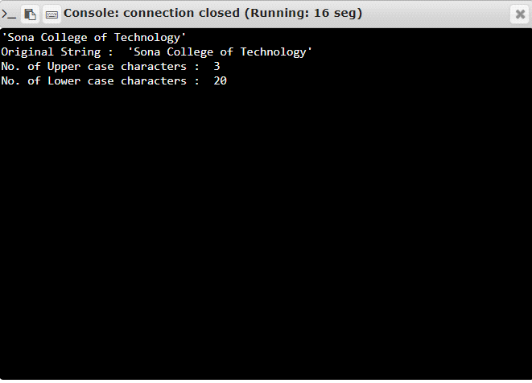

**Result:**

Thus, the program is successfully executed and the output is verified.